**Assignment 4**

#Laboratory Exercise 5, Home Assignment 4

.data

string: .space 50

Message1: .asciiz "what's your name : "

Message2: .asciiz "Your name length : "

.text

main:

get_string:

li $v0 ,54 # assign 54 to $v0

la $a0 , Message1 #load address of Message 1 to $a0

la $a1 , string #load address of Message 2 to $a1

la $a2 , 50 #load address of 50 to $a2

syscall #display Message 1

get_length:

la $a0 , string #load address of string to $a0

add $t1,$a0,$t0 #t1 = a0 + t0

check_char:

add $t1,$a0,$t0 # t1 = a0 + t0

lb $t2,0($t1)#load byte t1 and save to t2

beq $t2,$zero,end_of_str #if t2 = zero branch to end_of_str

addi $t0,$t0,1 #t0=t0+1

j check_char #loop

end_of_str:

end_of_get_length:

print_length:

li $v0 ,56 #assign 56 to v0

la $a0,Message2 #load address Message 2 to a0

add $a1,$t0,-1 #a1 = t0 -1

syscall #display Message 2

* **Bảng Text Segment**

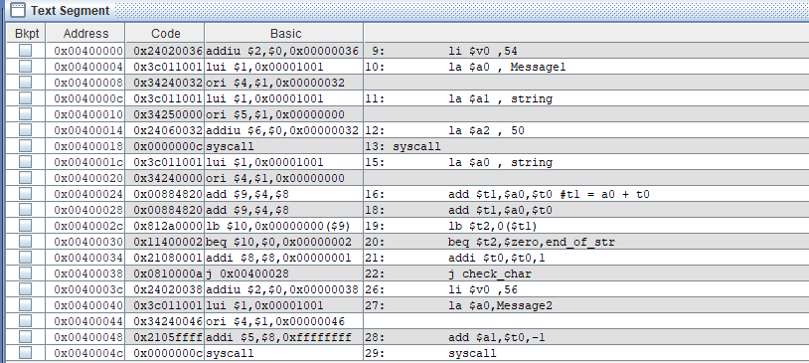

* Bảng giá trị của các thanh ghi

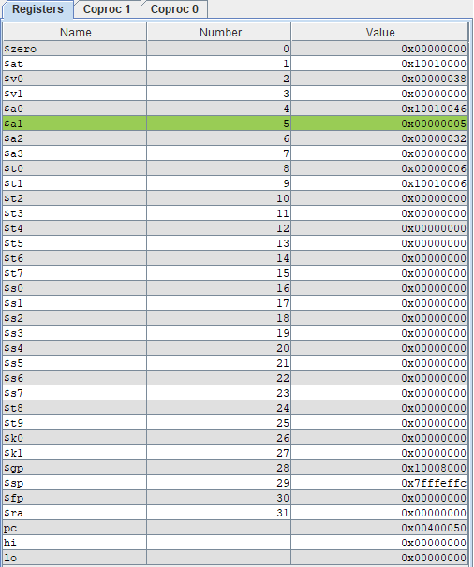

* Khi chạy chương trình

